**Headline TK- Covid-19 therapeutic supply lags as cases soar in Florida (TO BE UPDATED BASED ON CURRENT DATA)**

**Dek: TK**

The rapid development and authorization of Covid-19 therapeutics was meant to stem the impact of the tide of cases. But a restricted supply that fails to meet the demand has meant that these therapeutics remain out of the reach of many.

Antivirals, namely molnupiravir, developed by Merck and Ridgeback Biotherapeutics, and Pfizer’s Paxlovid, have generated particular interest given that they can be taken orally. GlaxoSmithKline’s sotrovimab, the only monoclonal antibody that works against the Omicron variant, rounds up the list of effective authorized therapeutics.

However, as per data gleaned from a Therapeutic locator dashboard run by the US Department of Health and Human Services (HHS), the supply of these therapeutics remains inadequate in comparison to the demand. Also, some places **like TK** are facing more of an acute shortage than others.

(States facing the biggest shortages of…

Paxlovid:   
  
Delaware – none, Florida – 4 available courses per 100,000 people, North Dakota – 3, Tennessee – 5, Alabama - 6 (national average = 22 per 100,000).

Molnu:

Delaware – none, North Dakota – 13 available courses per 100,000 people, Colorado 18 (national average = 123 per 100,000).

)

(Cities facing the biggest shortages of:

Paxlovid:  
  
0.5 available courses per 100,000 people, Orlando – none, Memphis – 0.15, Tampa – none (national average = 22 per 100,000).  
  
Molnu:  
  
Orlando – none, Tampa – none, Jacksonville – 11 available courses per 100,00, Detriot - 12 (national average = 123 per 100,000).

)

Many large states are receiving very small shares of US’s stock of therapeutics. **TK (previously Florida)**, (still Florida) for example, currently has under **80** available courses of either molnupiravir, ~~sotrovimab~~ and Paxlovid for every 100,000 people. In comparison, **Louisiana and Wisconsin** – states with similar Covid-19 cases levels to Florida – both have in excess of **200** available course per 100,000 people.

**Florida** currently accounts for over **5%** of all new Covid-19 cases in the US in the past seven days but only holds **3.6%** of all available courses **(including just 1.1% of available Paxlovid courses).** The other states with a shortage of therapeutics relative to Covid-19 patients include **Tennessee (3.1 % of cases, 0.8% of courses) and Colorado (1.4 of cases, 0.5% of courses)**.

Representative graphic (TO BE UPDATED)

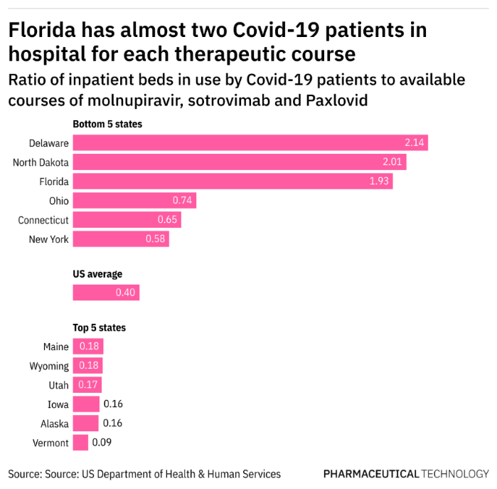

“Currently, the distribution of therapeutics is limited, and it is difficult for providers or patients to know where to go to get them,” says Michael Ganio, the director of pharmacy practice at American Society of Health Systems Pharmacists. “Even resources like the therapeutic locator can point you to where a site has at least received a shipment, but it doesn't mean they have it in stock”. The locator is said to be updated daily.

Even within **Florida** there are significant inequalities in the levels of available therapeutics. There are currently no facilities in **Orlando or Tampa** with available courses while centres in **Jacksonville** only have a short supply of Paxlovid available (**4** courses per 100,000 people). But Miami has more than **10 times** that rate of available Paxlovid at **50 courses per 100,000.**

At the other end of the scale, **Illinois** and **Mayland’s** shares of all available courses **(5.1% and 2.2%)** far exceed their share of new Covid-19 cases **(2.7% and 0.5%).**

**Maryland** appears to be one of the states with the most plentiful stock of allocated courses. It currently has just **new** **1.4 Covid-19 cases** for each available antiviral course. In contrast, both **Tennessee** and **North Dakota** have over **new 20 Covid-19 cases** for each available antiviral course.

**During the Omicron wave, cases levels started to decline earlier in Maryland than in most other states, and it currently has the lowest rate of new cases in the US. Maine stands out as one of the few states not to experience a dramatic increase in case rates during the recent Omicron surge, and yet it too has high stocks of available courses – currently 3 for every new case.**

**Since the HHS began publishing data on available courses of antivirals at the end of December, we have seen many states build stockpiles, particularly for molnupiravir. On January 11, Pennsylvania had just under 50 available courses of molnupiravir per 100,000 people. This more than doubled to over 115 by January 24 and increased to 163 per 100,000 people on February 2.**

**Meanwhile, stocks have been decreasing in other states. Colorado has 18 courses of molnupiravir per 100,000 compared to 26 in early January. Tennessee has also seen its available courses fall during the month – from 58 to 48 per 100,000 people.**

**Supply chain disrupted**

The majority of Covid-19 cases are mild in vaccinated, in particular boosted people, but there are still hospitalizations and even intensive care admissions, says epidemiology professor Dr Luis Ostrosky, which has been overwhelming the hospital system. “It has been challenging to meet the demand, “says Ostrosky who practices at the University of Texas Health Sciences Center at Houston.

As per AmerisourceBergen, the company contracted to distribute Covid-19 therapeutics, the HHS determines weekly distribution amounts based on new Covid-19 cases and hospitalizations in each state or territory, and inventory and usage data.

In practice, getting access to the antivirals requires providers or their offices to call around to different pharmacies so people can eventually get it. “It is challenging on pharmacists who are receiving phone calls asking if they have the therapies and on patients,” says Ganio.

**Representative graphic on therapeutic distribution vs Covid-19 cases TK TO BE UPDATED**

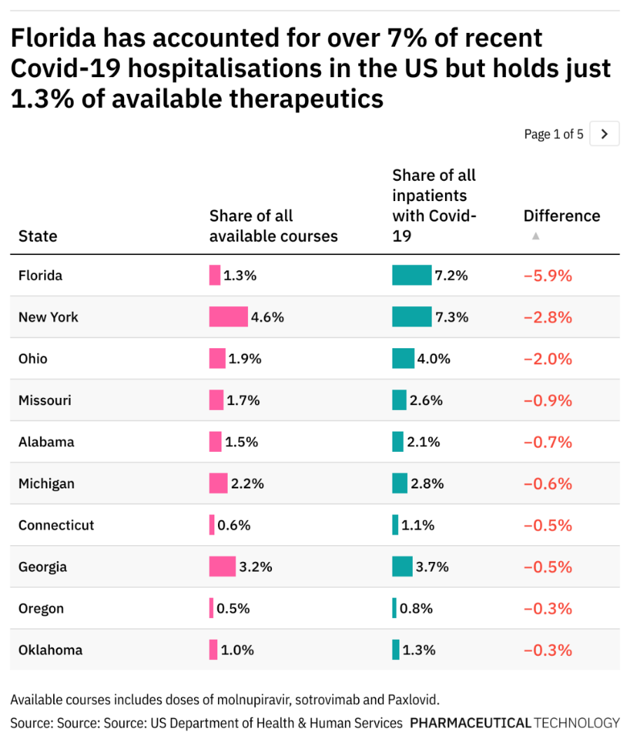

The Delta surge from earlier in 2021 affected the distribution system by a lot leaving a lasting impact. In early 2021, the government had stopped distribution and allocation, and through open access individual pharmacies could order the treatments, says Ganio. But, in order to maintain an equitable distribution, not just in terms of location and patient populations but also to ensure that there are enough supplies over time, the government took over the system again and this has continued over the most recent surge as well, he explains.

**Representative data graphic TO BE UPDATED**

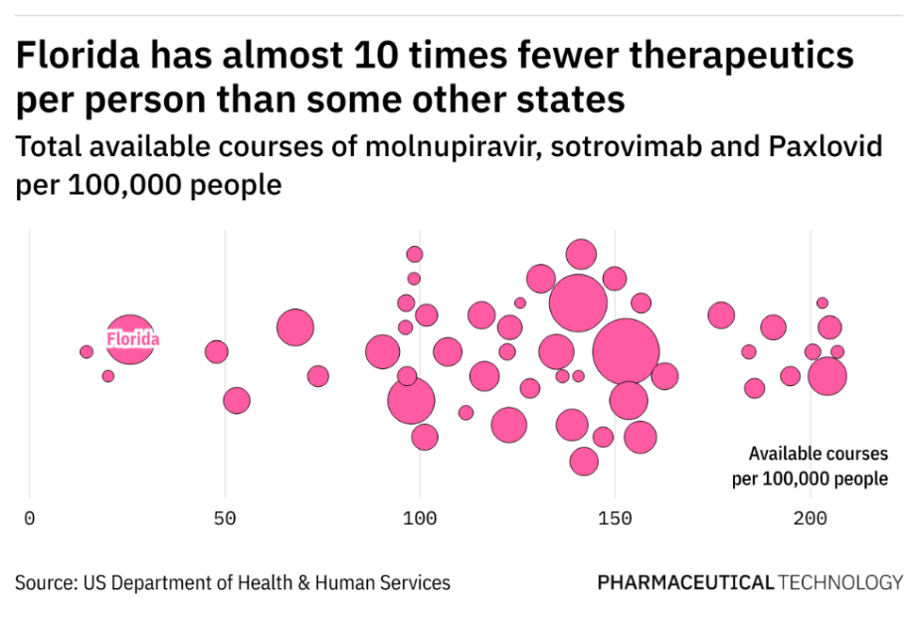

Omicron changed the supply dynamics significantly, because of its infectivity rate. Also, once it rendered other authorized mAbs by Eli Lilly and Regeneron ineffective, that reduced the number of effective treatments.

Details on [sotrovimab](https://www.pharmaceutical-technology.com/news/gsk-vir-sotrovimab-eua/), the only mAb treatment that is [effective against Omicron](https://www.pharmaceutical-technology.com/special-focus/covid-19/covid-19-gsk-sotrovimab-activity-omicron-variant/), currently the most dominant variant in most parts of the world, are not included in the therapeutic locator. A separate database maintained by the HHS that is updated weekly does include information on sotrovimab. A GSK spokesperson said the company did not have any information to provide on sotrovimab’s supply since the HHS was controlling the allocation and distribution. The HHS did not respond to a request for additional comment.

The therapeutic locator also includes information on Evusheld, AstraZeneca’s long-acting monoclonal antibody combination that is FDA authorized as a pre-exposure prophylactic. However, this mAb combination is specifically meant to prevent Covid-19 in individuals who are not currently infected or exposed to the virus.

“It has been challenging to get a reliable supply of sotrovimab to the point where it has to be prioritized for people who are more likely to benefit than others”, says Ostrosky. “When there was a reliable supply of the mAbs by Eli Lilly or Regeneron, there were no issues in getting it for patients, but now the supply is the rate-limiting factor”.

“It is important to ramp up production and increase distribution, because while Omicron is peaking in some places, it is barely starting in others,” Ostrosky says. “Even if a place hits the peak in infections, it will take four to six weeks to go down to pre-Omicron levels, so we're going to be in the situation of a high caseload in the US for at least the next 2-3 months”.